***Cicer Arietinum* .L(Chickpea) Distribution Modelling using Ecological Niche Model**

**Submitted By:**

**SreeChandra .V**

**Shivani Singh**

**Gayathri .B**

**Under Guidance of:**

**Dr. Rama Chandra Prasad**

**1.INTRODUCTION:**

The species is thought to be in critical danger of extinction. Chickpea uses whopping 76 gallons for every ounce. Droughts around the world have decreased chickpea production. We use various SDM models here to study about the production of chickpea in the coming years.

The SDM models we use for our study are: 1. Bioclim, 2.Domain ,3. GLM(generalized linear model) and 4.SVM(support vector machine) . Worldwide, millions of Statisticians and Data scientists use R to solve their most challenging problems in fields ranging from computational biology to quantitative marketing. We study these models, implement them and obtain results using the R software. We provide the future production of the species for the future climate(i.e. year 2070).

**2.overview**

**2.1 SDM(SPECIES DISTRIBUTION MODEL)**

Species distribution modelling (SDM) is also known under other names including climate envelope-modelling, habitat modelling, and (environmental or ecological) niche-modelling. The aim of SDM is to estimate the similarity of the conditions at any site to the conditions at the locations of known occurrence (and perhaps of non-occurrence) of a phenomenon. A common application of this method is to predict species ranges with climate data as predictors. In SDM, the following steps are usually taken: (1) locations of occurrence of a species (or other phenomenon) are compiled; (2) values of environmental predictor variables (such as climate) at these locations are extracted from spatial databases; (3) the environmental values are used to ﬁt a model to estimate similarity to the sites of occurrence, or another measure such as abundance of the species; (4) The model is used to predict the variable of interest across an the region of interest (and perhaps for a future or past climate).various SDM tools are: 1.GARP ,2.GLM,3.GAM,4.MAXENT,5.GBM,6.RANDOM FORESTS,7.BIOCLIM,8.MARBLE ALGORITHM,9.DOMAIN,10.MAHALANOBIS,11. MARS,12.SVM,13.ANN,14.CSMBS,15.ENF,16.CTA

**1.2 OVERVIEW OF THE SPECIES**

**1.2.1 Impact of climate on chickpea growth:**

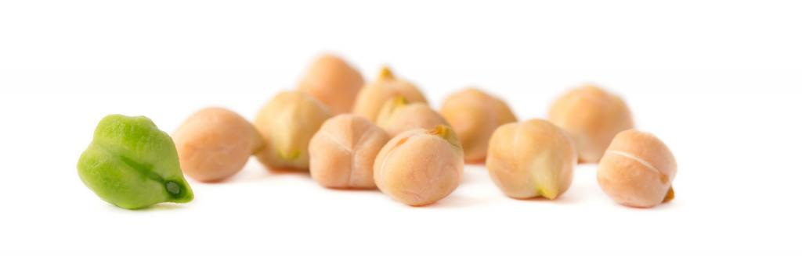

The chickpea plant grows very well under good moisture conditions.and the ideal temperature for growing chickpea is between 24ᵒ C and 30ᵒ C. Although the plants the plant can survive as low as 15ᵒC and as high as 35ᵒC.Annual rainfall of about 650 and 950 mm is ideal. The growth of plant at ambient temperature was significantly declined at elevated temperatures. The reduction in yield was low (10%) at 26/16 °C, moderate (23%) at 30/18 °C and very severe at 34/18 °C (64%) and 38/22 °C (78%). The yield related traits most affected by high temperature were pod number and harvest index. It is concluded that for heat tolerance in chickpea, breeding efforts needs to be focused on improving the reproductive efficiency.

**1.2.2 Overview of R software:**

R is a free software environment for statistical computing and graphics. It compiles and runson a wide variety of UNIX platforms, Windows and MacOS.Many users think of R as a statistics system. We prefer to think of it of an environmentwithin which statistical techniques are implemented. R can be extended (easily) viapackages. There are about eight packages supplied with the R distribution and many moreare available through the CRAN family of Internet sites covering a very wide range ofmodern statistics.During the last decade, the momentum coming from both academia and industry has liftedthe R programming language to become the single most important tool for computationalstatistics, visualization and data science. Worldwide, millions of statisticians and datascientists use R to solve their most challenging problems in fields ranging fromcomputational biology to quantitative marketing. R has become the most popular languagefor data science and an essential tool for Finance and analytics-driven companies such asGoogle, Facebook, and LinkedIn.

**3. MATERIALS AND METHODS**

**3.1 SPECIES AREA OF STUDY:**

Chickpea is mostly cultivated in India, Middle East and parts of Africa .We study the chickpea occurrences in India.

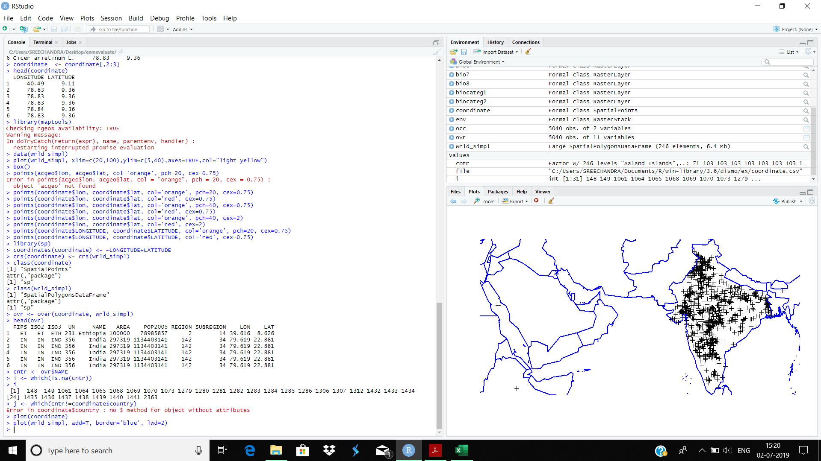

Fig showing Data points of species *CICER ARIETINUM .L* in India

**3.2 DATA PREPARATION**

The species “CicerArietinum .L” data is downloaded from GBIF database. Data preparation has many steps like:

**3.2.1 Data cleaning**

Data ’cleaning’ is particularly important for data sourced from species distribution data warehouses such as GBIF. There are few errors in the data downloaded from GBIF and there is need to clear these points.

**3.2.2 Duplicate records**

There are chances that a record occurs twice in the data provided by GBIF. This could happen because plant samples are often split and sent to multiple Herbariums.

**3.2.3 Cross-Checking:**

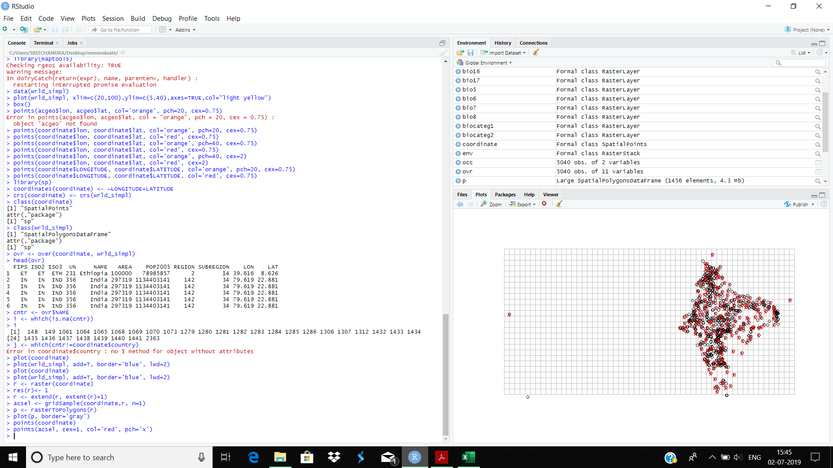It is important to cross-check coordinates by visual and other means. One approach is to compare the country (and lower level administrative subdivisions) of the site as speciﬁed by the records, with the country implied by the coordinate.

**3.2.4 Sampling bias:**

Sampling bias is frequently present in occurrence records.One can attempt to remove some of the bias by subsampling records.subsampling reduces the number of records, and it cannot correct the data for areas that have not been sampled at all.



**3.3 ENVIRONMENTAL DATA:**

**3.3.1 RASTER DATA**

In species distribution modelling, predictor variables are typically organized as raster (grid) type files. Each predictor should be a ’raster’ representing a variable of interest. Variables can include climatic, soil, and other variables. In this study we have used climate as the predictor variable called as bioclimatic variables. The bioclimatic variables are downloaded from worldclim.org . There are 19 bioclimatic variables. The resolution used for climate data is 10 minutes of a degree. Bioclimatic variables are derived from the monthly temperature and rainfall values in order to generate more biologically meaningful variables. They are coded as follows:

BIO1 = Annual Mean Temperature

BIO2 = Mean Diurnal Range (Mean of monthly (max temp - min temp))

BIO3 = Isothermality (BIO2/BIO7) (* 100)

BIO4 = Temperature Seasonality (standard deviation *100)

BIO5 = Max Temperature of Warmest Month

BIO6 = Min Temperature of Coldest Month

BIO7 = Temperature Annual Range (BIO5-BIO6)

BIO8 = Mean Temperature of Wettest Quarter

BIO9 = Mean Temperature of Driest Quarter

BIO10 = Mean Temperature of Warmest Quarter

BIO11 = Mean Temperature of Coldest Quarter

BIO12 = Annual Precipitation

BIO13 = Precipitation of Wettest Month

BIO14 = Precipitation of Driest Month

BIO15 = Precipitation Seasonality (Coefficient of Variation)

BIO16 = Precipitation of Wettest Quarter

BIO17 = Precipitation of Driest Quarter

BIO18 = Precipitation of Warmest Quarter

BIO19 = Precipitation of Coldest Quarter

For the future model prediction, the same set of bioclimatic variables pertaining to the year 2070 were downloaded from WorldClim website. The model considered here is “AC”model of CMIP5 and resolution used is 10 minutes of a degree.

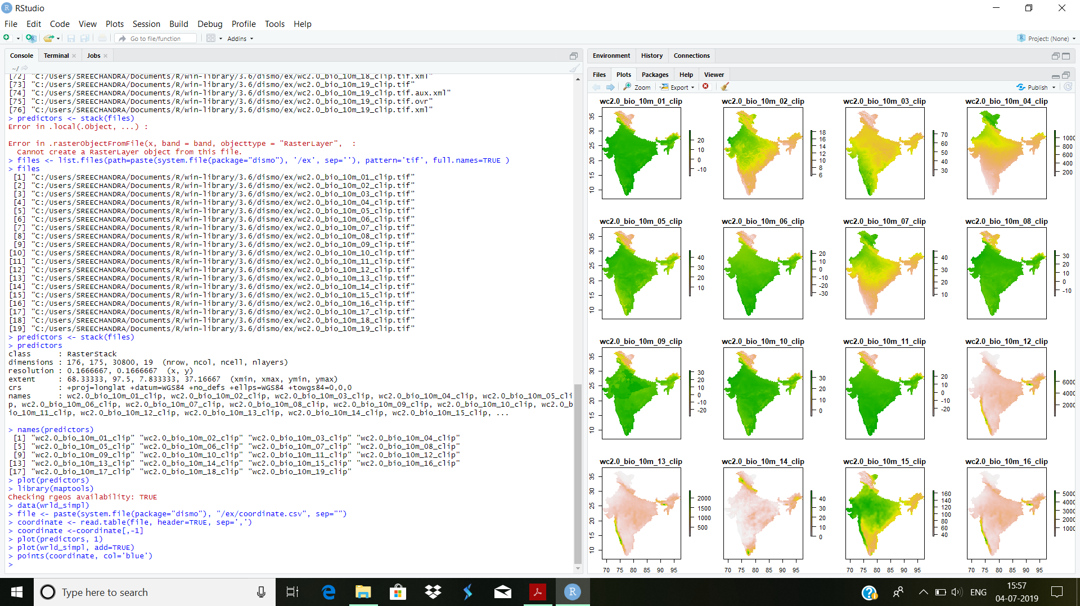



**3.5 EXTRACTING VALUES FROM THE RASTER:**

We now have a set of predictor variables (rasters) and occurrence points. The next step is to extract the values of the predictors at the locations of the points.

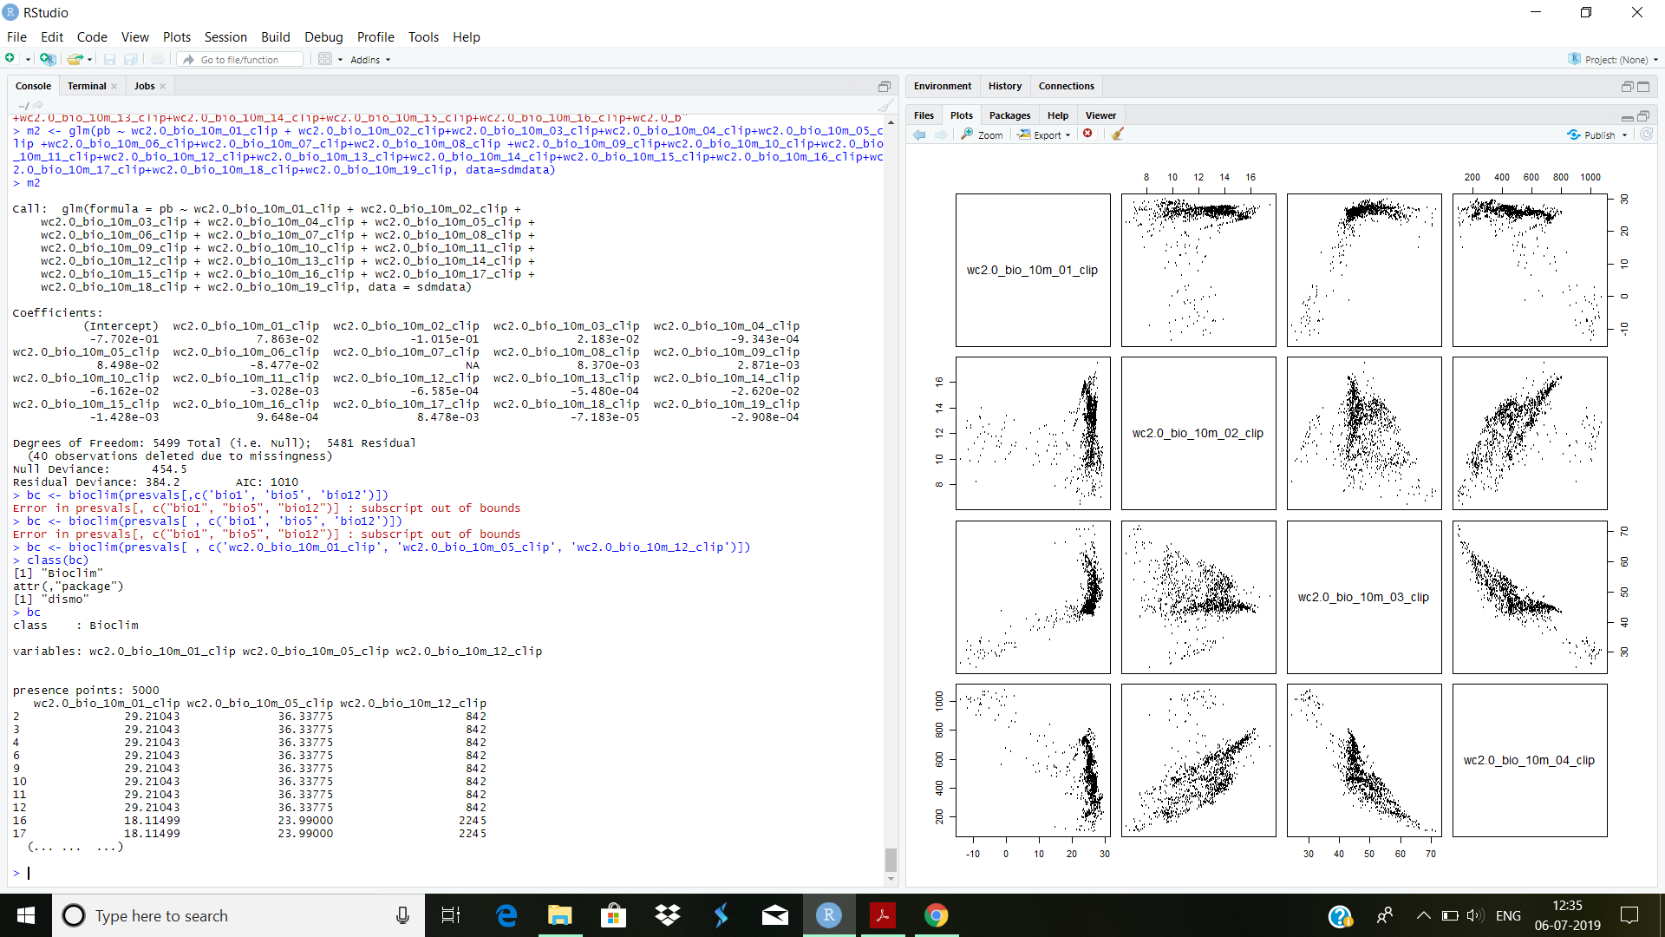



**4.MODELLING PROCEDURE and IMPLEMENTATION:**

In this document, we use various species distribution modelling algorithms for the existing chickpea data and we evaluate them for results.

1.Model fitting

2. Model prediction

3.Model evaluation

4.Dividing the dataset into Test and Train data

The following algorithms are used for modelling:

(a)Profile Methods

* Bioclim
* Domain

(b)Regression Method

* GLM

(c)Machine Learning Method

* SVM

**4.1 MODEL FITTING**

Model ﬁtting is technically quite similar across the modeling methods that exist in R . Most methods take a ’formula’ identifying the dependent and independent variables, accompanied with a data.frame that holds these variables.

>pairs(bc)

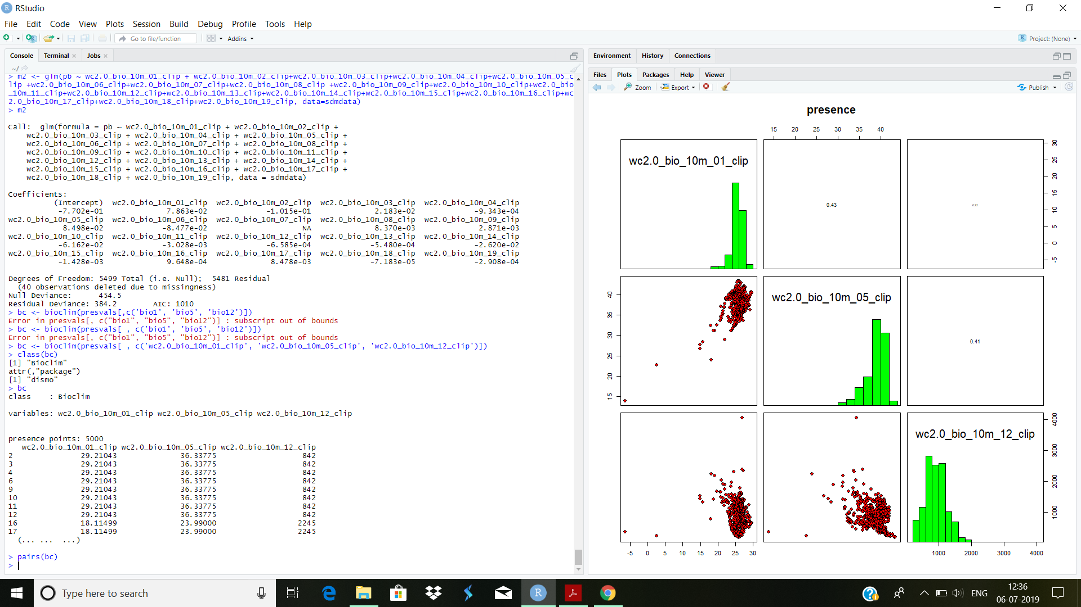

**4.2 MODEL PREDICTION:**

Diﬀerent modeling methods return diﬀerent type of ’model’ objects. All of these ’model’ objects, irrespective of their exact class, can be used to with the predict function to make predictions for any combination of values of the independent variables.This is illustrated in the example below where we make predictions with the glm model object ’m1’ and for bioclim model ’bc’, for three records with values for variables bio1, bio5 and bio12 (the variables used in the example above to create the model objects).

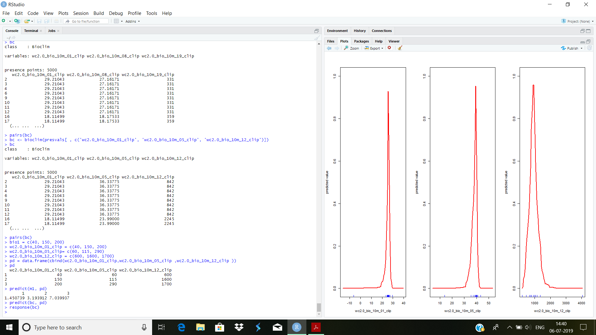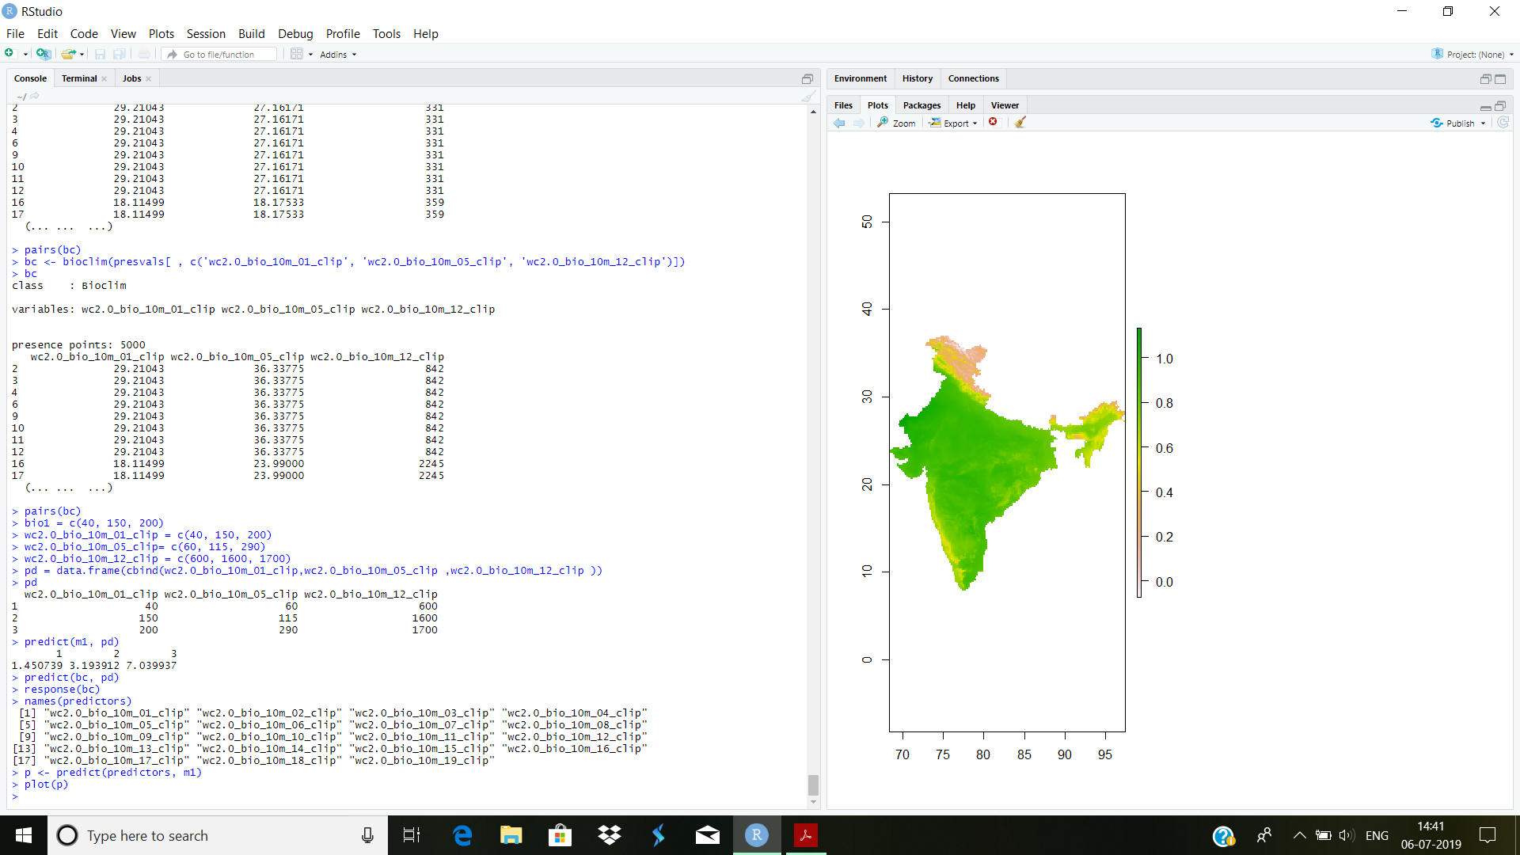

**4.3 MODEL EVALUATION:**

It is much easier to create a model and make a prediction than to assess how good the model is, and whether it is can be used for a speciﬁc purpose. Most model types have diﬀerent measures that can help to assess how good the model ﬁts the data. Most statistics or machine learning texts will provide some details. For instance, for a GLM one can look at how much deviance is explained, whether there are patterns in the residuals, whether there are points with high leverage and so on. However, since many models are to be used for prediction, much evaluation is focused on how well the model predicts to points not used in model training.

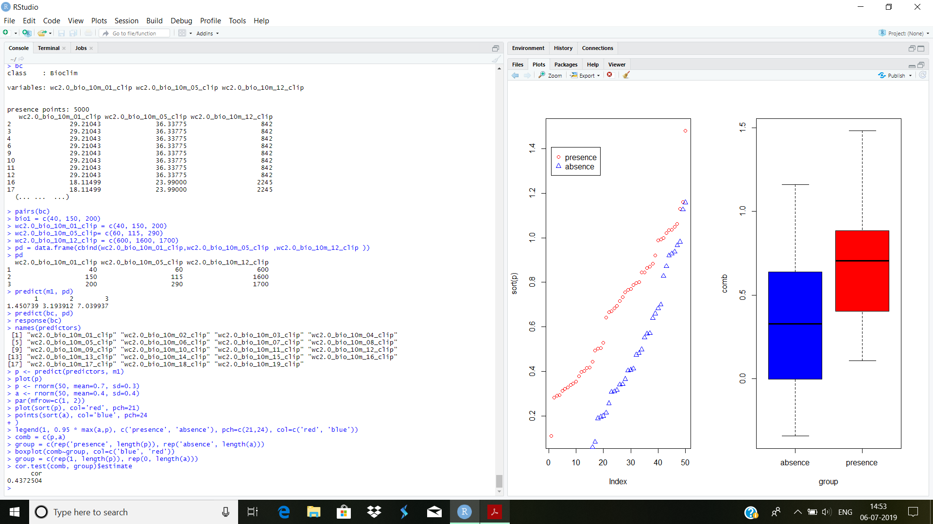

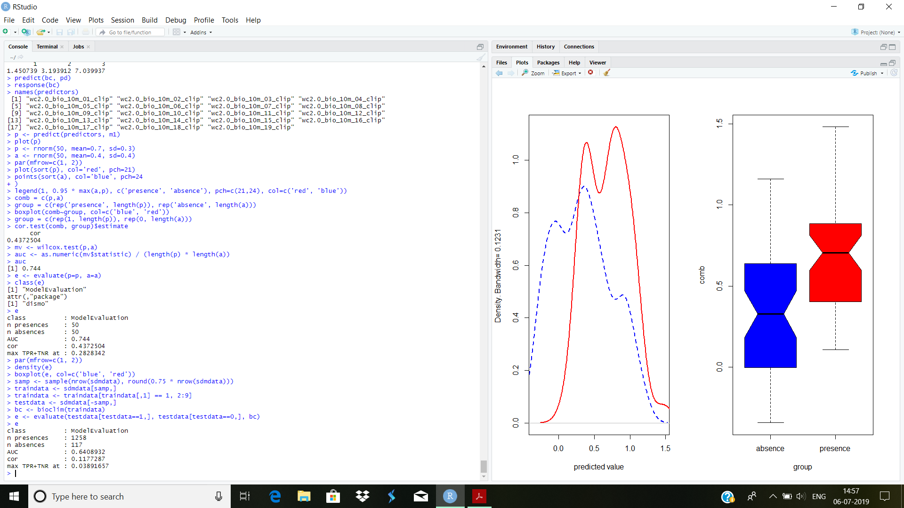

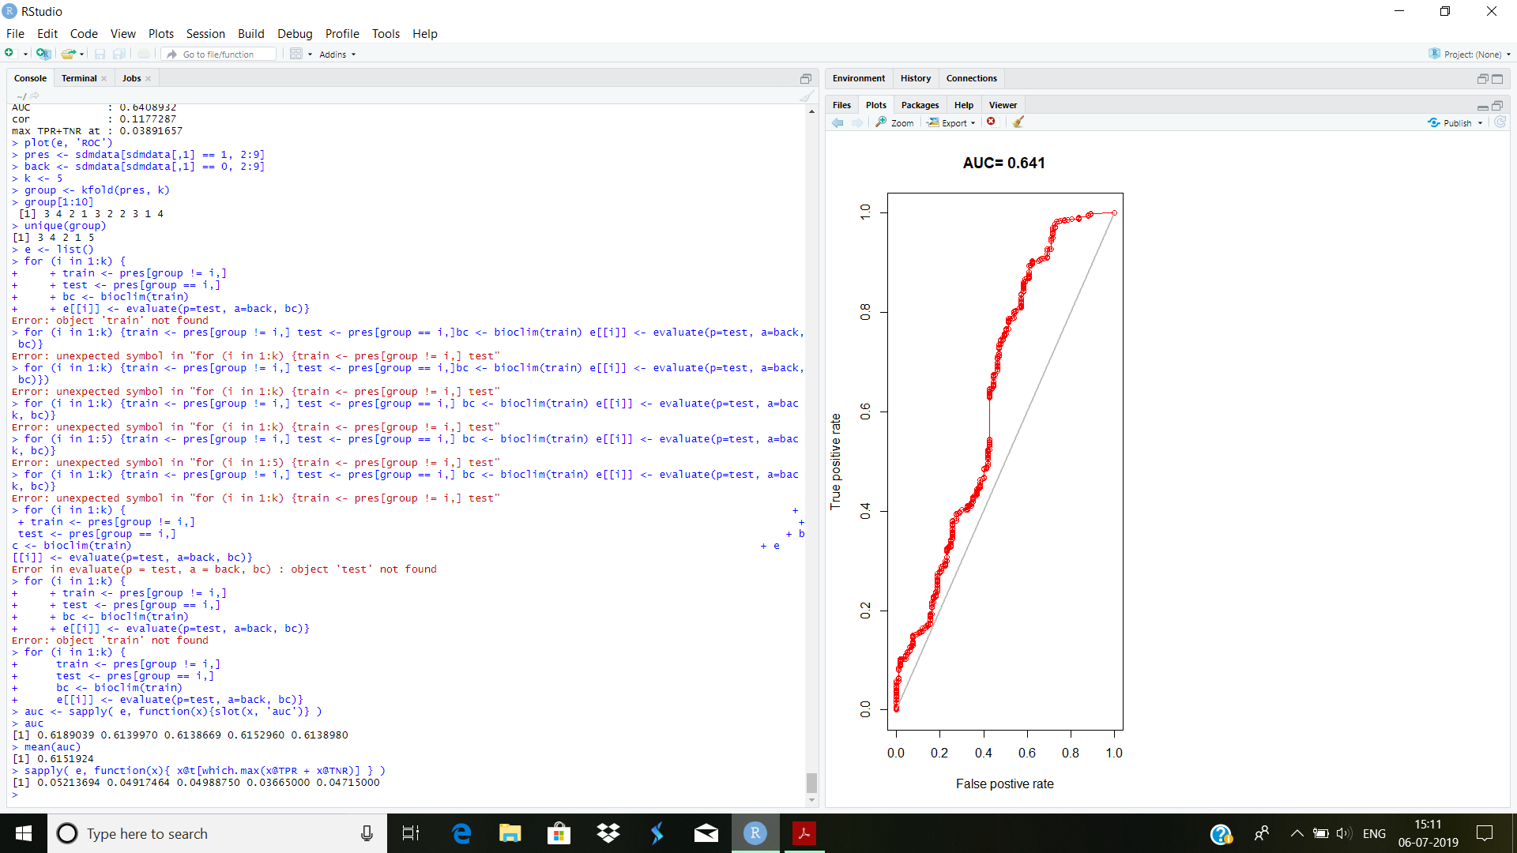

**4.4 DIVIDING THE DATA AINTO TEST AND TRAIN DATA:**

Cross-validation is done which consists of creating a model with one ’training’ data set, and testing it with another data set of known occurrences. Typically, training and testing data are created through random sampling (without replacement) from a single data set.

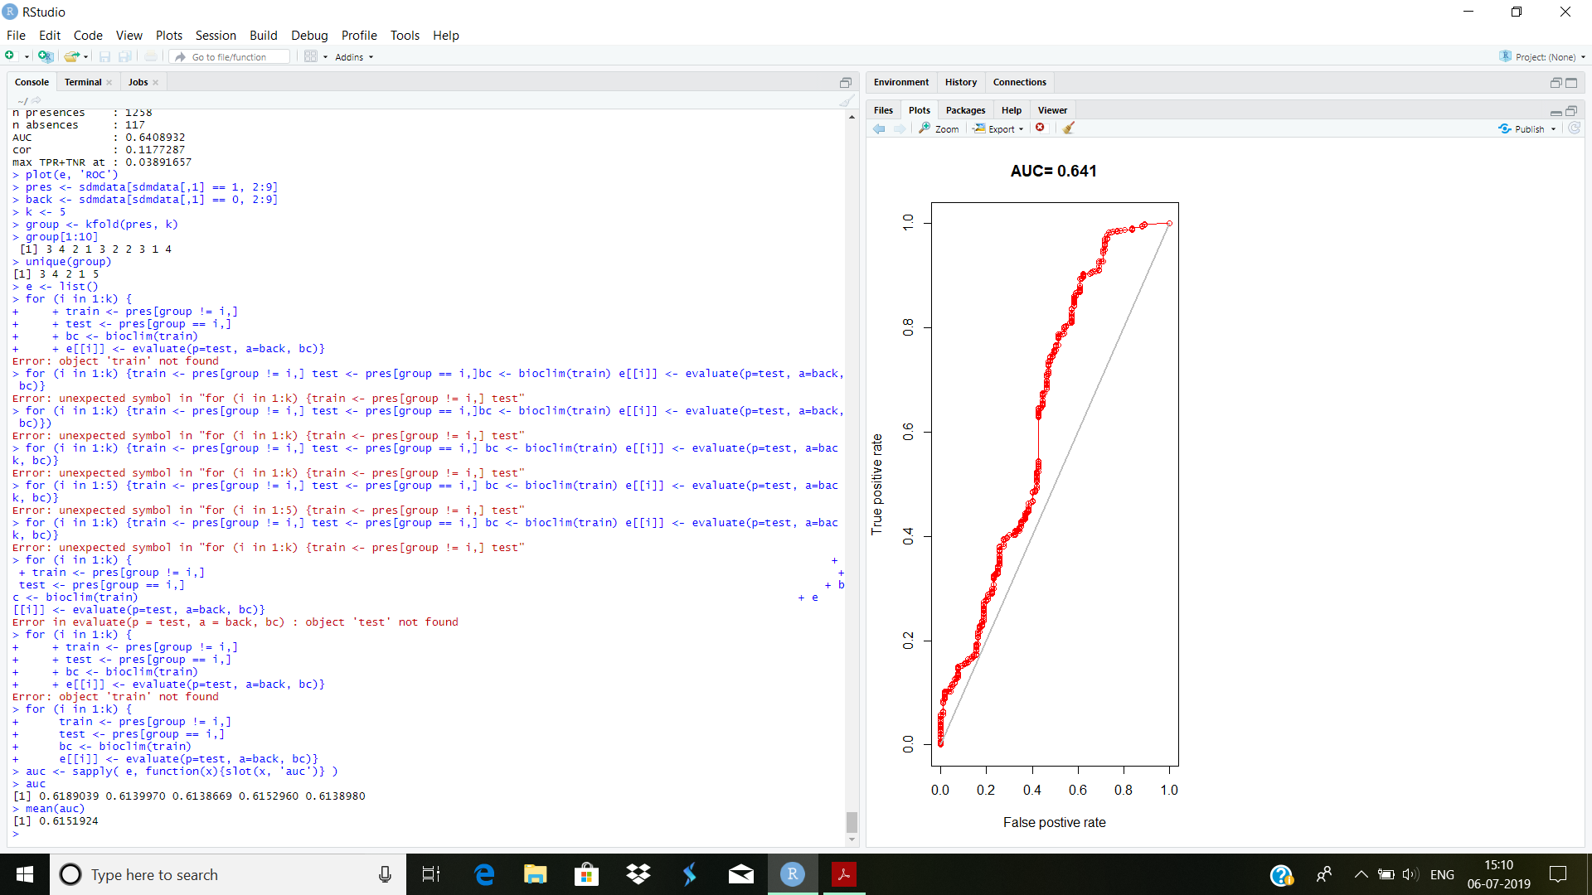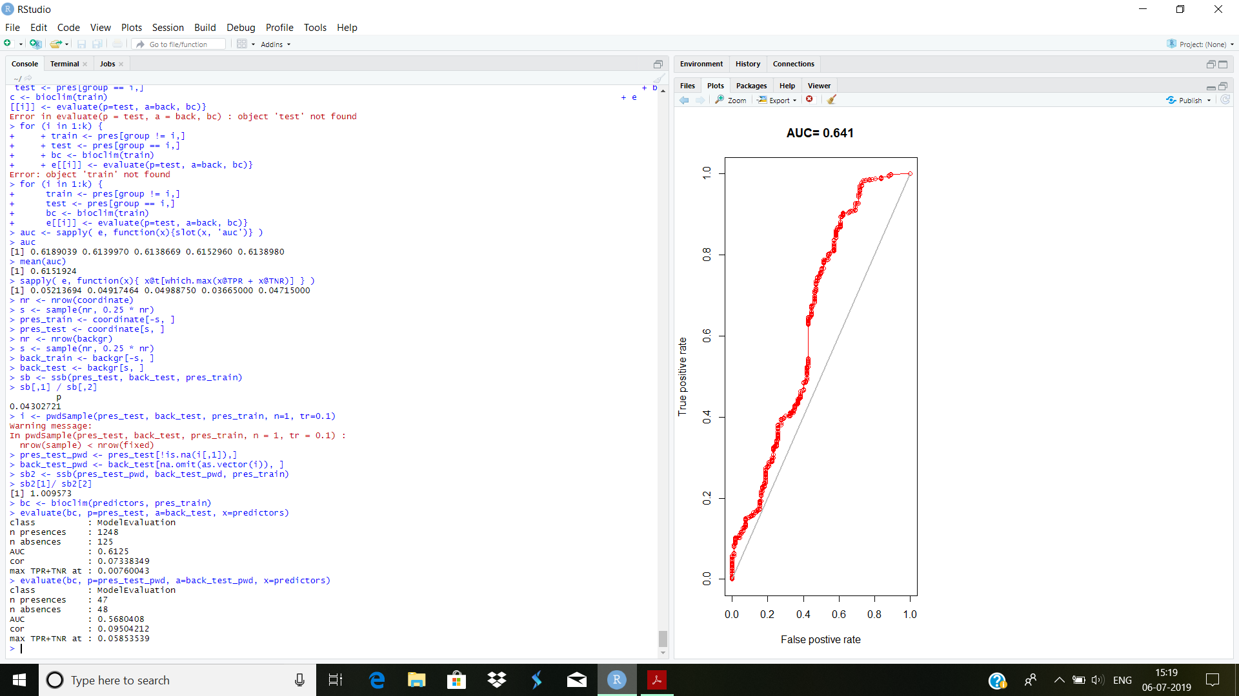

**5.DISTRIBUTION MODELLING OF SPECIES “ CICER ARIETINUM .L “: USING VARIOUS ALGORITHMS:**

A large number of algorithms has been used in species distribution modelling. They can be classiﬁed as ’proﬁle’, ’regression’, and ’machine learning’ methods.

* 1. **Profile methods:**

These methods are implemented in the dismo package, and the procedures to usethese models are the same.

* + 1. **BIOCLIM**

BIOCLIM is a classic ’climate-envelope-model’.Although it generally does not perform as good as some other modelling methods, particularly in the context of climate change and, it is still used, among other reasons because the algorithm iseasy to understand and thus useful in teaching species distribution 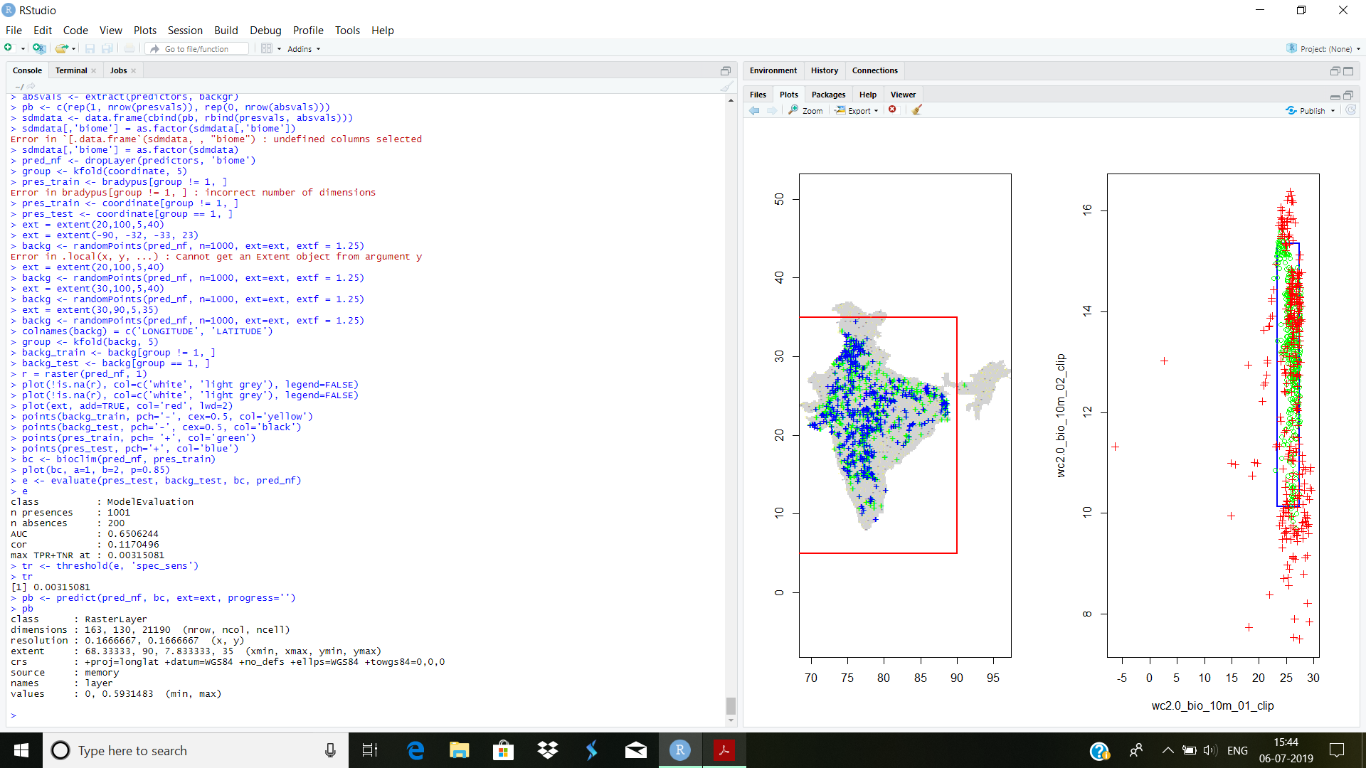modelling.The closer tothe 50th percentile (the median), the more suitable the location is. The tailsof the distribution are not distinguished, that is, 10 percentile is treated asequivalent to 90 percentile.



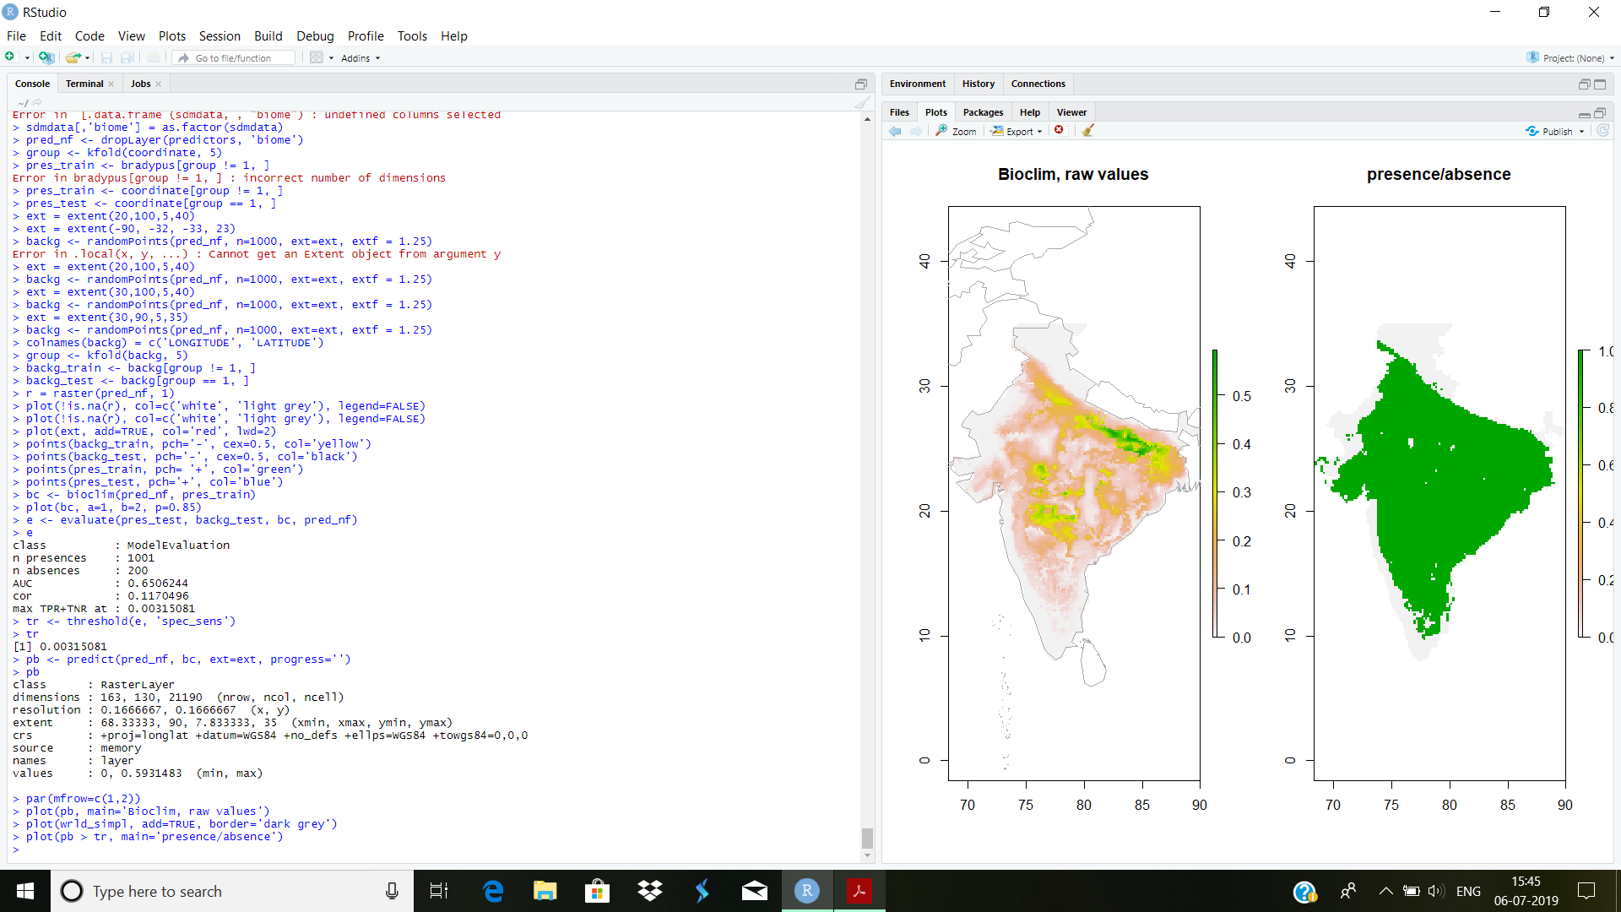

**5.1.2DOMAIN**

The Domain algorithm has been extensively used

for species distribution modelling. It did not perform very well in a model

comparison and very poorly when assessing climate change

effects.Below we fit a domain model, evaluate it, and make a prediction. We map

the prediction, as well as a map subjectively classified into presence / absence.

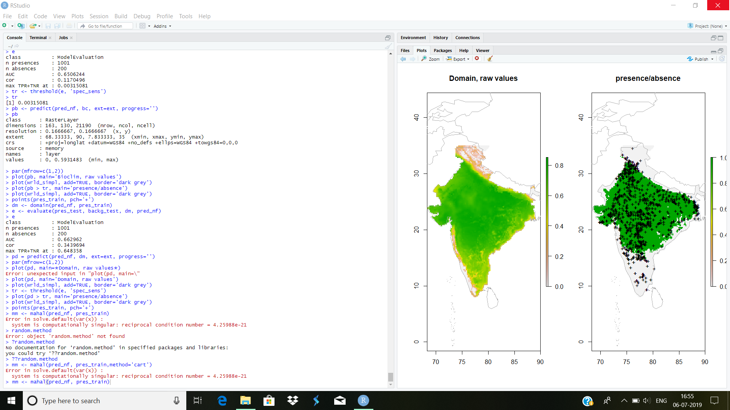



**5.2 REGRESSION MODELS**

The remaining models need to be fit with presence and absence (background)

data. With the exception of ’maxent’, we cannot fit the model with a Raster-

Stack and points. Instead, we need to extract the environmental data values

ourselves, and fit the models with these values.

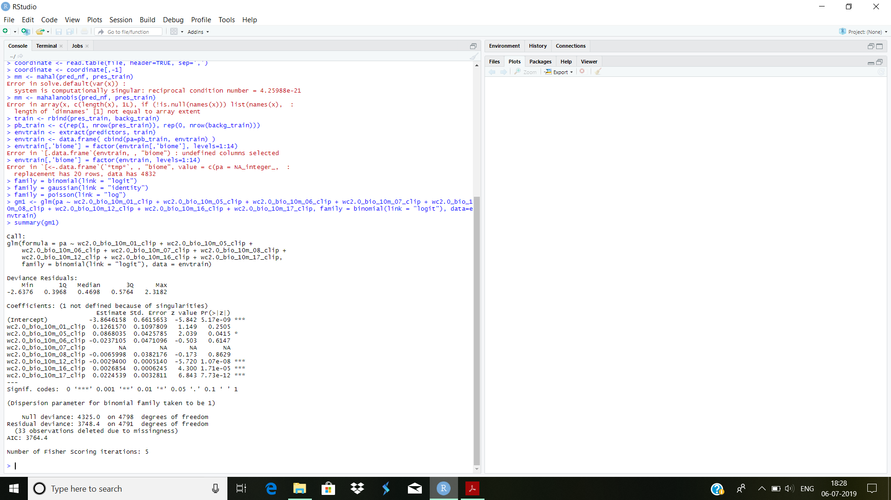

**5.2.1 GLM(Generalized Linear Models)**

A generalized linear model (GLM) is a generalization of ordinary least squaresregression. Models are fit using maximum likelihood and by allowing the linearmodel to be related to the response variable via a link function and by allowingthe magnitude of the variance of each measurement to be a function of its predicted value. Depending on how a GLM is specified it can be equivalent to(multiple) linear regression, logistic regression or Poisson regression.

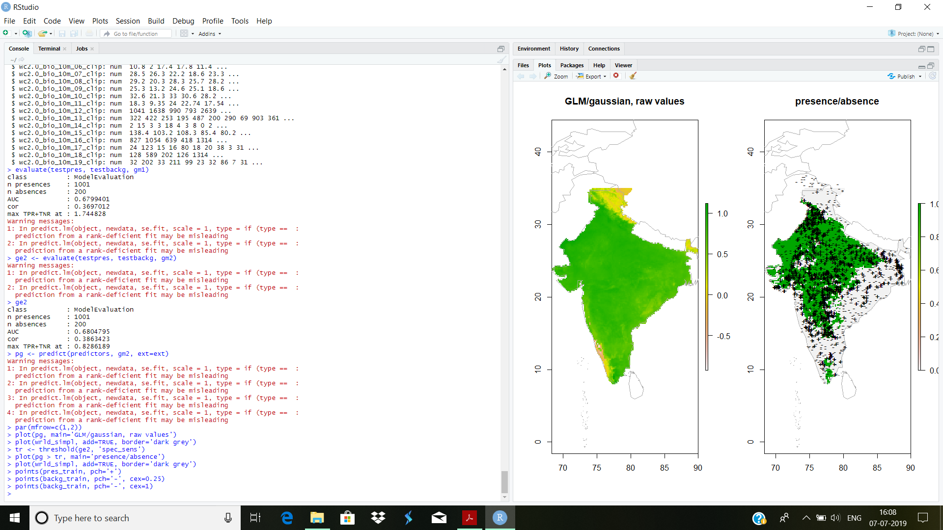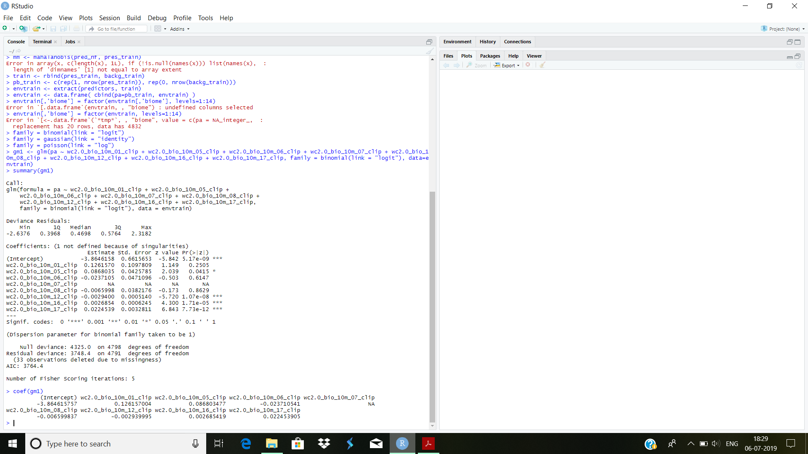



**5.3MACHINE LEARNING METHODS**

There is a variety of machine learning (sometimes referred to data mining)methods in R .For a long time there have been packages to do Artifical NeuralNetworks (ANN) and Classification and Regression Trees (CART). More recentmethods include Random Forests, Boosted Regression Trees, and SupportVector Machines.

**5.3.1SUPPORT VECTOR MACHINES(SVM)**

Support VectorMachines (SVMs; Vapnik, 1998) apply a simple linear methodto the data but in a high-dimensional feature space non-linearly related to theinput space, but in practice, it does not involve any computations in that highdimensionalspace.They werefirst used in species distribution modeling by Guo et al. (2005).

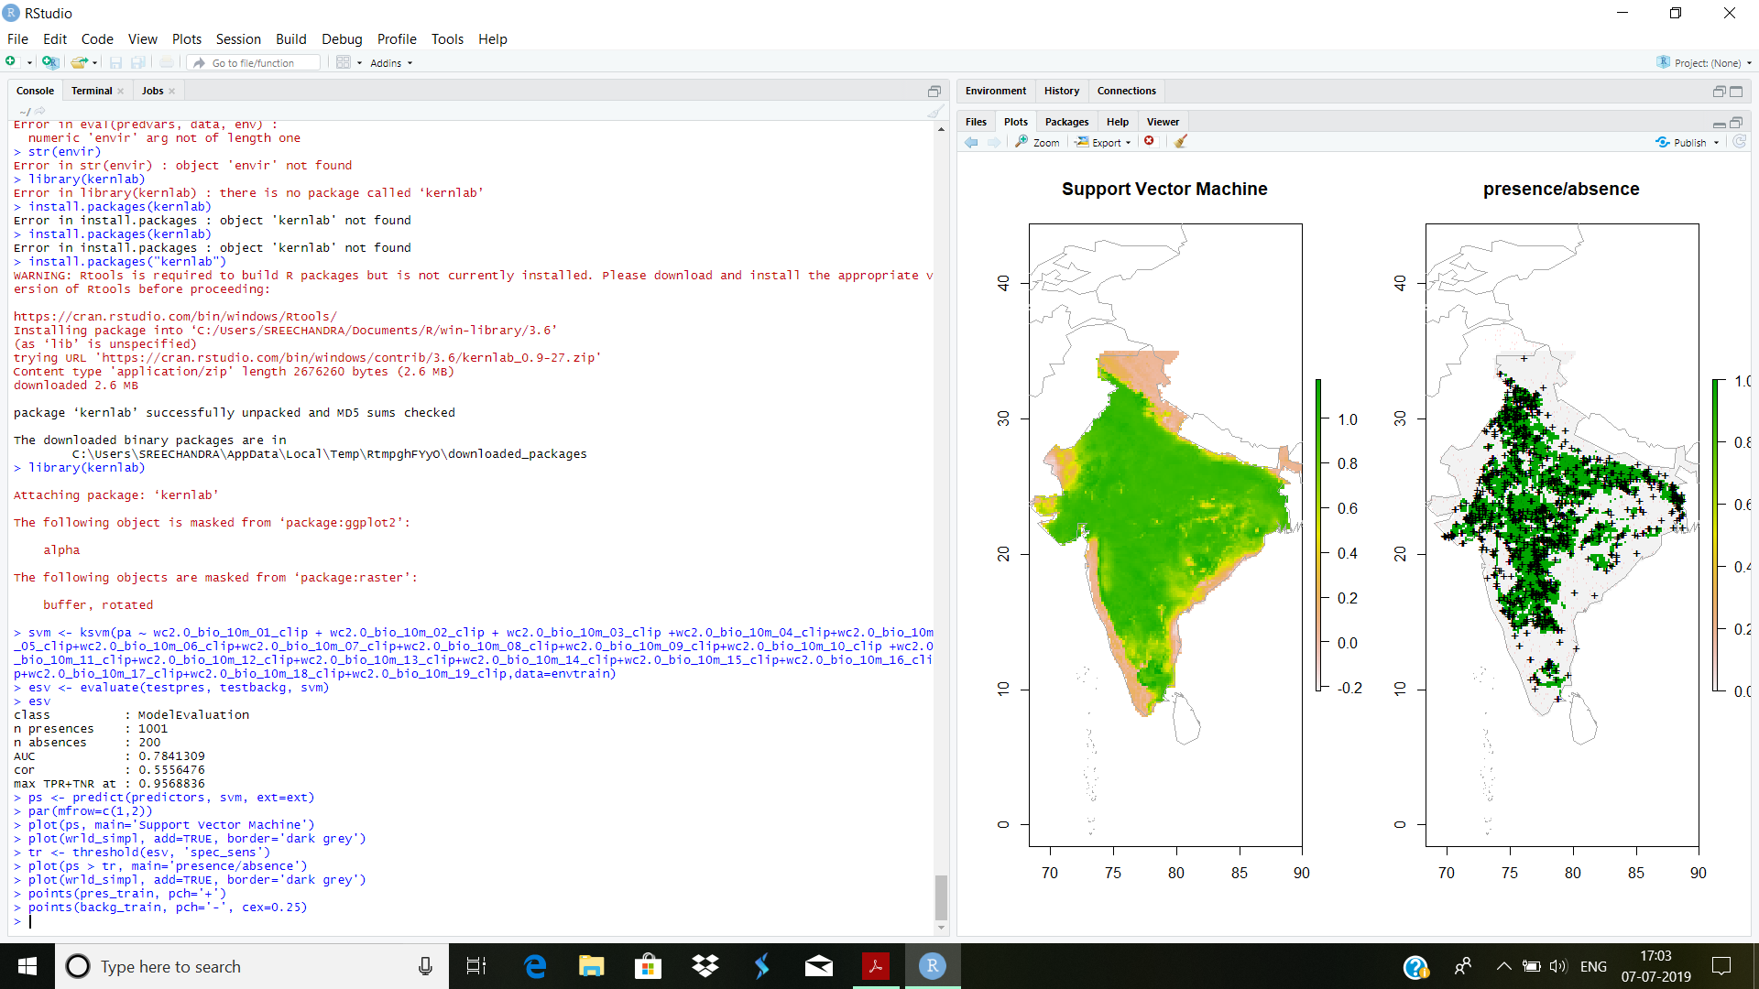

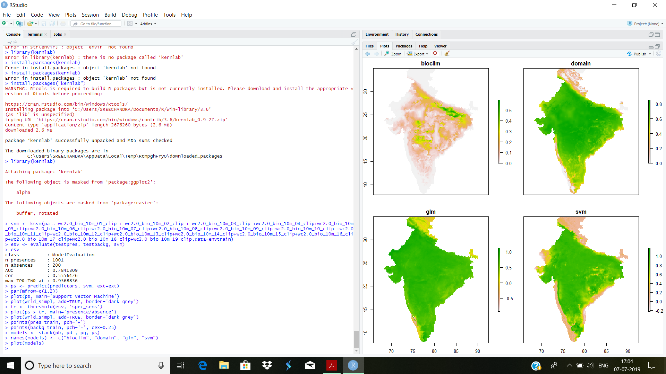

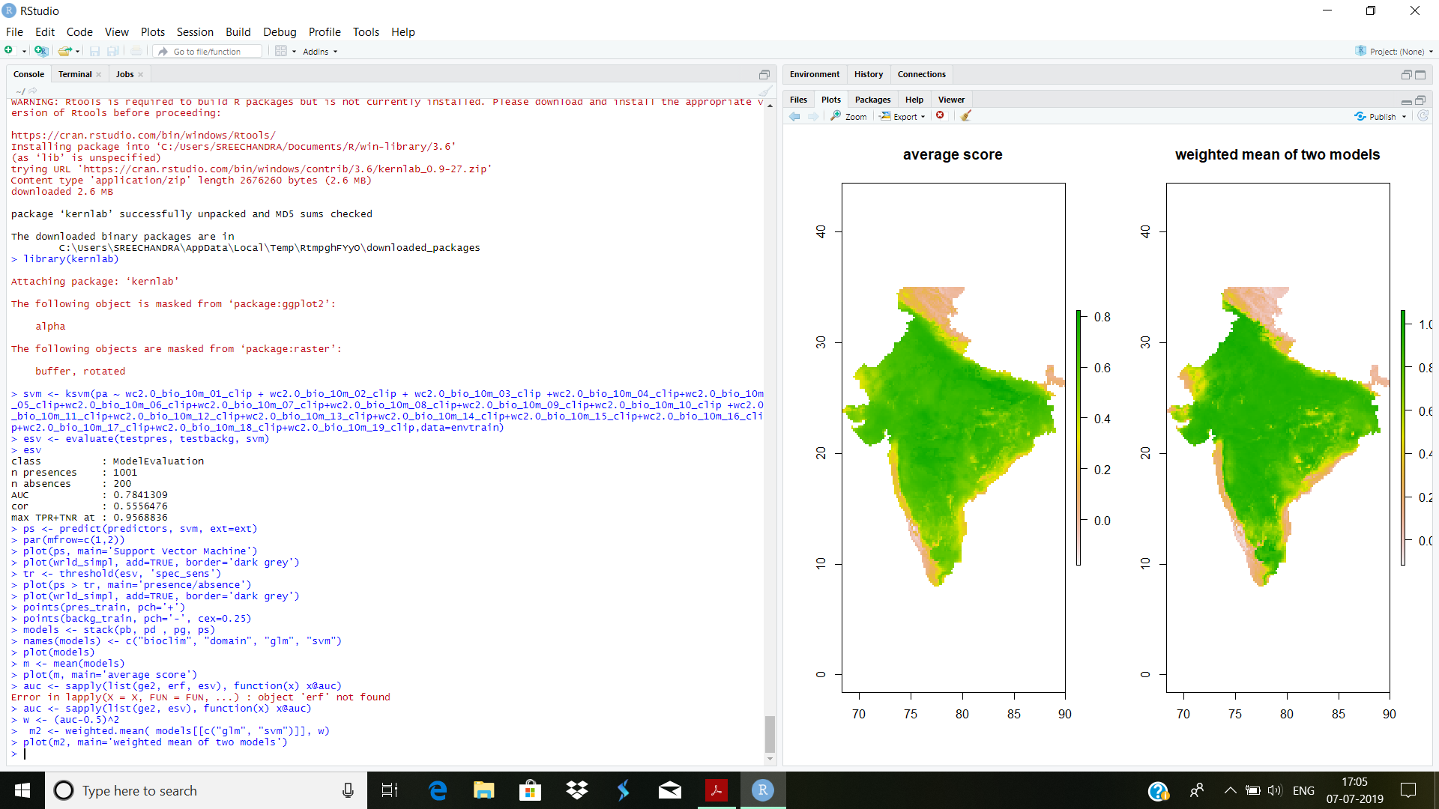**5.4COMBINING MODEL PREDICTIONS:**

**5.5 PREDICTING THE DISTRIBUTION OF SPECIES “CICER ARIETINUM.L” FOR CLIMATE 2070 USING VARIOUS MODELS**

**5.5.1 BIOCLIM**

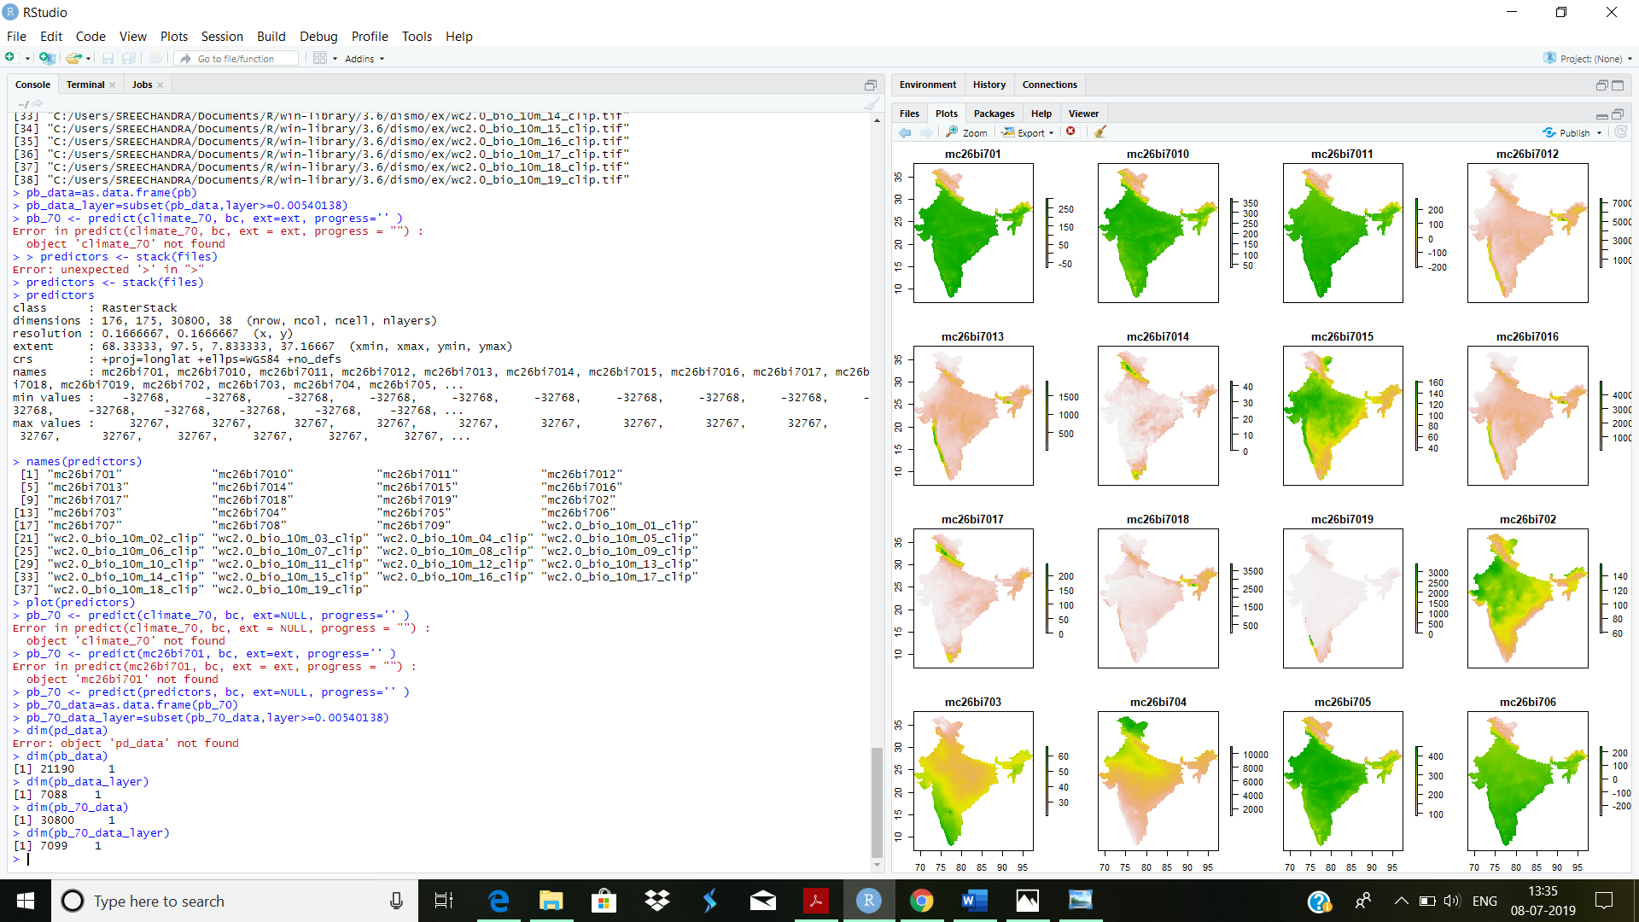Bioclim model is built using present climate and present species distribution data and it is used to predict the distribution of species for Climate 2070.



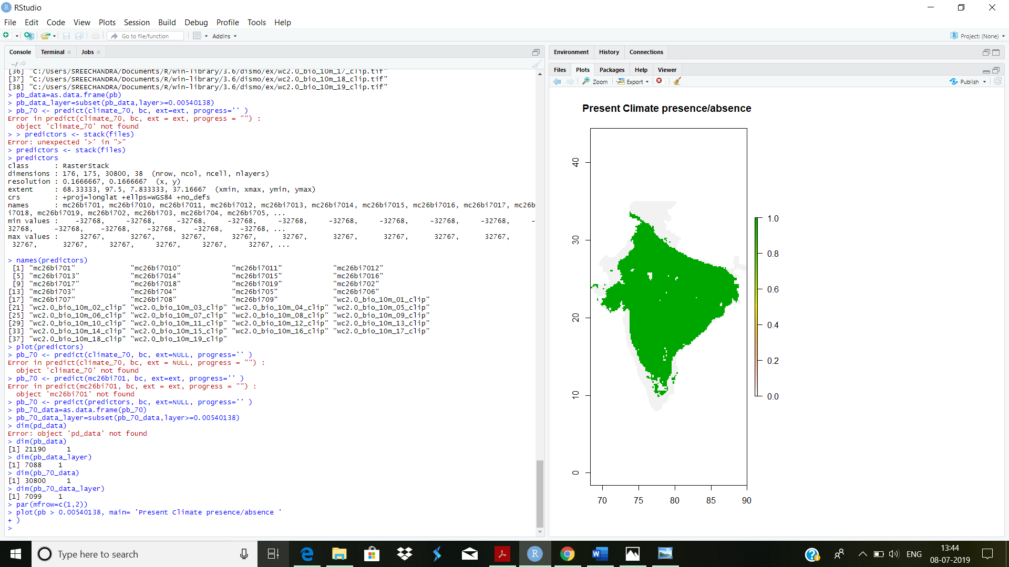

**6.CALCULATION OF PERCENTAGE REDUCTION IN PRODUCTION OF CHICKPEA FOR CLIMATE 2070**

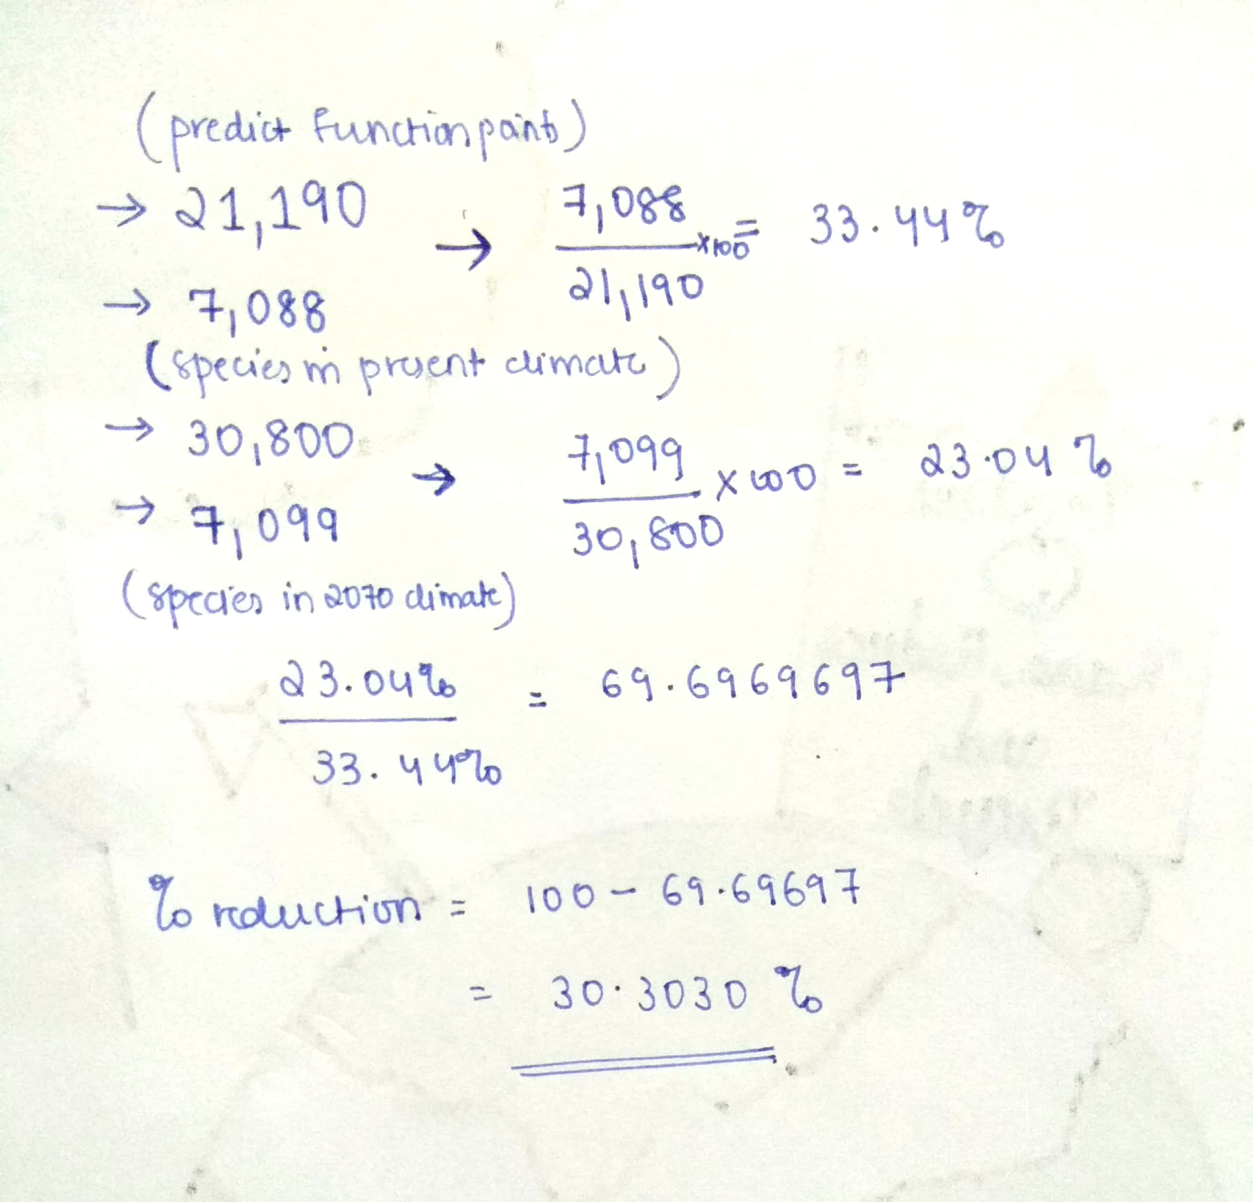

**7.CONCLUSION**

In this study, we successfully modeled the habitat suitability of CicerArietinum.L for the current and future climate change scenarios. This study concludes that the habitat suitability of CicerArietinum.L will reduce under the climate change scenario for the year 2070. We recommend to include future climate scenario in the existing restoration and conservation strategies for the protection of ecologically sensitive species in the existing habitat to avoid future extinction.

**8.ACKNOLEDGEMENT**

Firstly, we would like to thank Ravi Vundavalli sir secretary of OSGEO-INDIA and Dr. Rama Chandra Prasad , professor at IIIT-HYD for giving us the opportunity to do internship.

We would also like to thank the students of Spatial Informatics Lab who helping us with patience and with their openness, in solving and created an enjoyable environment.

We would also like thank the head of department of CSE Dr.Aruna Varanasi for being constructive a supportive throughout our internship.

It is indeed with a great sense of pleasure and immense sense of gratitude that we acknowledge with these individuals.

**9.REFERENCES**